|  |
| --- |
| Circle Language Spec: Commands |

## Command Calls in a Command Reference in a Diagram

This article demonstrates a situation of command objects.

This article illustrates how command calls in a command reference look in a diagram.

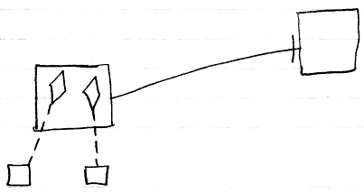

The square on the left is a command reference, because it points out its target definition, the square on the right, with a solid line, an object line. The command reference contains two command calls, displayed as diamonds. Those diamonds are calls, because they point out their definitions, the smaller squares at the bottom, with class lines, dashed lines. The square on the right could also have displayed the same calls, because both larger squares represent the same command object, that have the same contents.

The command reference and its target could also be replaced with a diamond arbitrarily, which make the command reference or target command executable.